





**Knott End Working Men’s Club**

**Salisbury Avenue**

**Knott End**

**FY6 0BP**

**Tel: 01253 812 226/01253 810 362 Email : knottendwmc@gmail.com**

**Enjoying the Gala, why not come on down to Knott End Working Men’s Club and enjoy the available facilities and a nice drink.**

**We have live sports in the Games Room, which also has snooker tables, pool table and a darts board and free wi-fi.**

**We also have a lounge area if you require something a bit more peaceful and a beer garden with outdoor seating.**





**We have an extensive range of alcoholic and non alcoholic drinks available that are reasonably priced and served in a friendly atmosphere.**

**We have a concert room that is available for hire for special events and on a Saturday night we have live entertainment.**

**We have Bingo, Open the Box, Raffle and the tote every Thursday, Saturday and Sunday.**

**If you would like to become a member visit the website or ask one of the staff inside.**

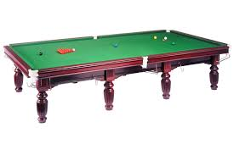



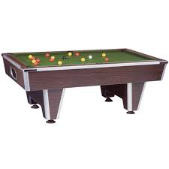

Further club details are available at [www.knottendwmc.co.uk](http://www.knottendwmc.co.uk) and our Facebook page